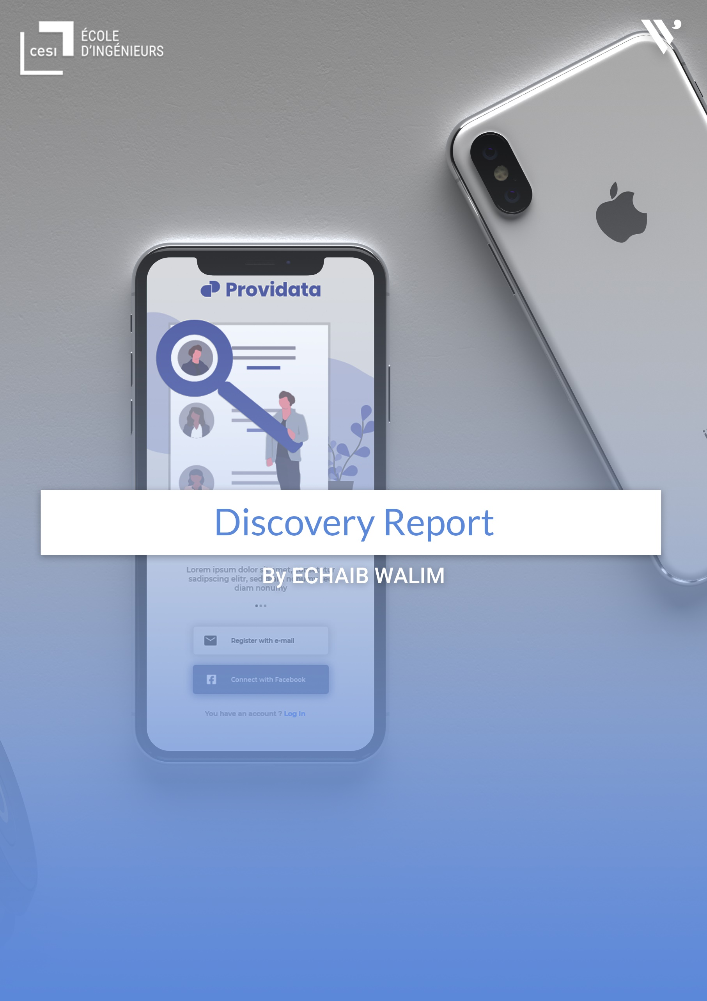

Table of content

Introduction of the company 3

Welcome in my new environment 5

Observations 5

Discovery Report 6

Summary of the work: 7

Planning of the last 4 weeks: 10

Conclusion 13

# Introduction of the company



Vibrand is a start-up founded in 2019 by two experts, one in digital marketing and communication and the other in graphic design.

Its goal is to develop from an agency to a studio in order to diversify its services in the world of communication and audio visual whether on the national territory or outside the borders where the market is more fruitful and vast.

They offer various services mainly dedicated to companies that are characterized in:

- The management of the customer's identity on the Internet: that is to say that the image that people will have of this company will be defined by audio visual and informative campaigns that will aim to make the customer known.

- Elaboration of strategies related to the digital aspect of the box: which consists in establishing plans for the organization of sponsorship campaigns related to certain events organized for the promotion of products etc...

- Creation of IT solutions that can correspond to a specific need, tailor-made and easy to handle thanks to the know-how of developers who do everything to guarantee a better user experience.

- Photo shooting and filming of promotional clips.

**Organization Chart:**

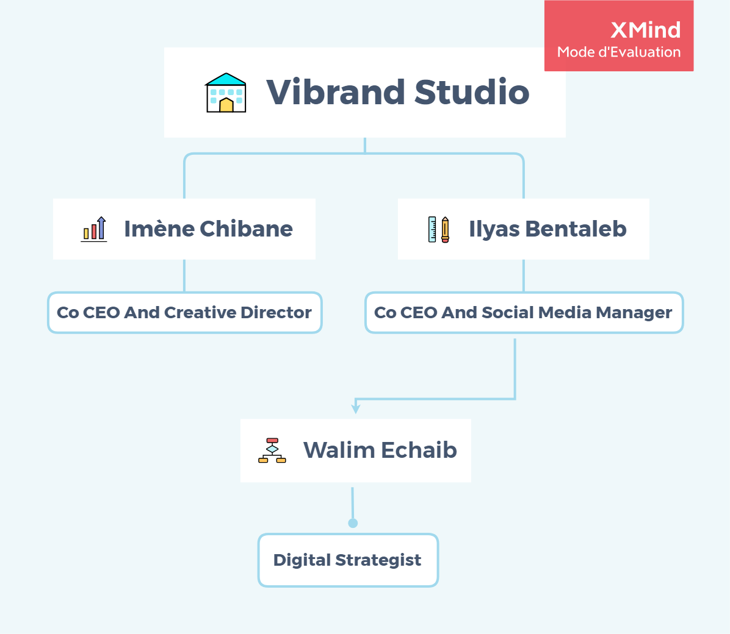

# Welcome in my new environment

Every working environment is different from the previous one and will be different in the future, this has to do with the people you work with (their involvement in what they do) but also with the workspace and the tools provided, in my case because of COVID-19 and the drop in orders I have to telework so this criterion is not really taken into account in my discovery report.

# Observations

**The recruitment process:**

Recruitment for the moment is closed, but their recruitment strategy is based on human criteria because, according to them, good manners take precedence over the professional aspect that is acquired through experience.

**The organisation:**

For the organisational aspect, on receipt of a task a deadline is set for its completion, always one day before delivery to the client so that the work can be validated by the manager.

**Internal communication:**

For the moment, everything is organised in a Slack group allowing the sharing of ideas and answers to questions about a specific task or its realisation, but also to schedule meetings to set up a workload plan.

**Inter-colleague relations:**

At the moment, there are not many collaborators within the start-up so that there is not much conflict or disagreement - everything is focused on the work that is done remotely.

**Relations with managers:**

As far as the relationship with the managers is concerned, there is a fairly good understanding because they consider their employees as partners and not as employees.

**The working environment:**

As said before, because of COVID-19 we are teleworking and do not share premises, but once a month we share the time of a week of the premises for a bootcamp and to establish a workload plan allowing us to consult on the arrival of new clients or to prepare meetings with the client.

**The tools at my disposal:**

No tools have been made available to me for this internship.

# Discovery Report

The activity report is an important document because it will enable the school to better follow the trainee during his or her placement, but also to know whether the trainee is putting into practice the main tasks for which he or she will be judged on the day of the defence.

It will also allow the student trainee to better situate himself, to see if the method he used to manage his internship was the right one, in which case he will be able to start writing down the main functions he occupied during his internship in order to start his internship report.

# Summary of the work:

This practical internship is for me an opportunity to apply the knowledge acquired at CESI but above all to learn new technologies so that they can be mastered by the end of the course.

The first thing that was done was to summaries all the tasks to be done to put some order into the management of the project by establishing rules.

**Objectives pursued:**

1. To design a mobile utility for making important data available.
2. To make important data available on the device accessible on the web platform.
3. Manipulate extracted data to multiply its uses.
4. To be able to find contacts in case of theft or loss of the device.
5. Apply the knowledge learned at school.

**Details of the project:**

Utility solution enabling a user to keep certain information (contacts, messages, notes, passwords etc....) accessible online in the event of loss of a device or emergency, he will be able to have it available using a web application.

**Functionalities:**

On the user side, a mobile application that will contain the following functionalities:

1. Classic authentication system with e-mail address.
2. Possibility to authenticate using a third-party application (Facebook, Google or other).
3. Account verification system.
4. E-mail notification system.
5. Synchronization of contacts and messages.
6. Password manager.
7. Create, Edit, Read and Delete Notes.
8. Backup files.
9. Saving albums for images.
10. Backup e-book.
11. Accessing settings.
12. Profile management.

It is also essential to create a web platform for the user to retrieve and update their data that will contain practically the same functionality as the mobile application.

**Administrator**

1. Dashboard
2. User management
3. Data management
4. History
5. Pack management
6. Parameter management.

**Conception:**

A diagram has been established in order to model the starting architecture and order the data to follow a logical relational order, the relationships revolve around the user who is the master of the application, each table represents a functionality.

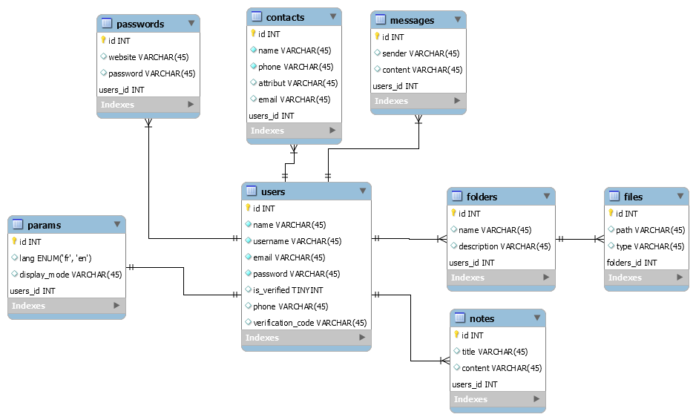

A prototypical model of the application has been created to preview the application and the different possible interactions. It is available on the following link (interactive model: <https://xd.adobe.com/view/f74cfed2-d02c-4776-4ff2-88c3cada6983-817d/> )

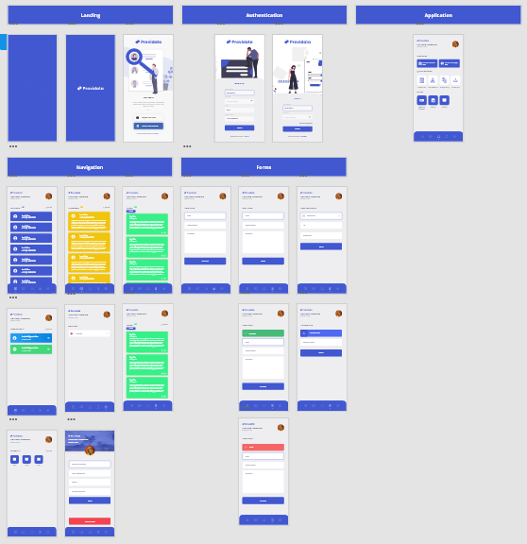

**API Conception:**



A token-based API has been designed to allow our different entities (web platform and mobile application) to operate via calls using HTTP requests.

# Planning of the last 4 weeks:

|  |  |  |
| --- | --- | --- |
| **Actual Schedule** | | |
| **Week 1** | | |
| **Day** | **Task** | **Note** |
| Sunday (start 04/10/2020) | * Signing of the documents | * The documents including the internship agreements and the validation form. |
| Monday | * Creation of specifications. | * To start any project, it is necessary to draw up a schedule of conditions including the smallest details, constraints, and specifications to carry out a project while respecting the client's request. |
| Tuesday | * Analysis of the specifications | * Once created, it will need to be analysed and dissected to ensure proper application of the application. |
| Wednesday | * Project set-up | * Creation of the different files I will need during this internship to properly structure my architecture including a mobile application, and my API. * This project is available on the following link for any consultation or verification: <https://github.com/therealwalim/gegevens-verstrekken> |
| Thursday | * Creation of Kanban board for project management. * Assignment of tasks and establishment of a workload plan for the course. | * For this assignment we agreed to use Trello, which is a free tool for structuring a project and managing the teams working on the project. * Kanban is a visual system for managing work as it moves through a process. Kanban visualizes both the process (the workflow) and the actual work passing through that process. The goal of Kanban is to identify potential bottlenecks in your process and fix them so work can flow through it cost-effectively at an optimal speed or throughput. |
| **Week 2** | | |
| Sunday | * Realization of the database diagram. | * Analysis of the data provided by the company with the help of specifications, a basic architecture having already been provided made it easier for us to design our database, but some contradictions forced us to modify the initial plan so that it could be adapted to expectations. |
| Monday | * Confirmation of all relationships between tables. * Creation of migrations. | * Migrations allow us to create tables, attributes, indexes, and foreign keys in our database. |
| Tuesday | * Creation of Models. * Checking the relationships between tables. | * Eloquent (which is an ORM) allows tables to be represented as objects to simplify record manipulation. |
| Wednesday | * Start of the mock-up of the mobile application using Adobe XD (Experience Design). | * Adobe XD is the all-in-one UX/UI solution for designing websites, mobile apps, and more. Design, prototype, share. All in XD. |
| Thursday | * Prototyping of the visual wireframe to make it interactive and animated. |  |
| **Week 3** | | |
| Sunday | * Beginning of the design of the API, which in my case will serve as my back end. * Configuration of the development environment. | * Setting up the connection with the database with verification of the associated ports, live server to emulate my back-end part and configuration of my mail capture tool which will allow me to capture the mails sent. |
| Monday | * Creation of controllers allowing me to receive messages and contacts. |  |
| Tuesday | * Creation and configuration of controllers allowing me to create, delete, update or display notes and passwords. |  |
| Wednesday | * Creation of a file storage system. | * Each time a file has to be stored, the user will have to indicate the name of the storage file, if it already exists the file will be stored there, otherwise the folder will be created and the file put in it. |
| Thursday | * Installation of Laravel Sanctum. * Sanctum configuration. * Creation of a registration system. * Setting up a connection system (allocation of tokens) to users. * Implementation of a system of disconnection (deletion of tokens) to users. | * Laravel Sanctum provides a featherweight authentication system for SPAs (single page applications), mobile applications, and simple, token-based APIs. Sanctum allows each user of your application to generate multiple API tokens for their account. These tokens may be granted abilities / scopes which specify which actions the tokens can perform. |

# Conclusion

We can conclude that these first weeks of internships have allowed me to put into practice some of the notions I learned during my time at CESI while learning new things that will be essential for my apprenticeship.